**CS566-Iowa Market Place App-System Design**

1. **Login page**

1. **Register page**

1. **Main page**

1. **Profile Page**
2. **Regular User – Products Tab**

1. **Regular User – My Bids Tab**

1. **Regular User – General Tab**

1. **Admin – Products Tab**

1. **Admin – Users Tab**

1. **Show Bids Modal**

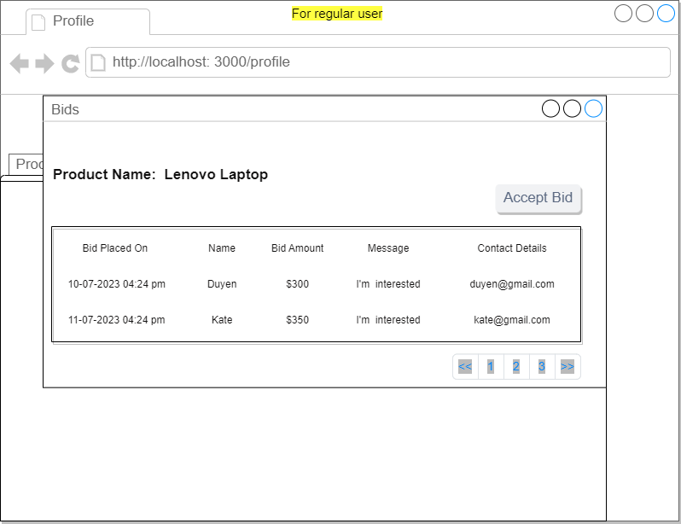

1. **Product Details page**

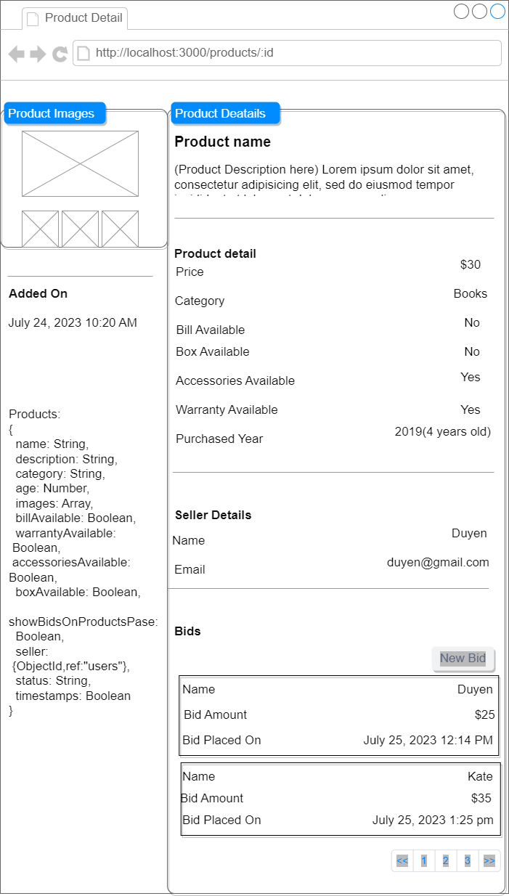

1. **Add Product Modal**

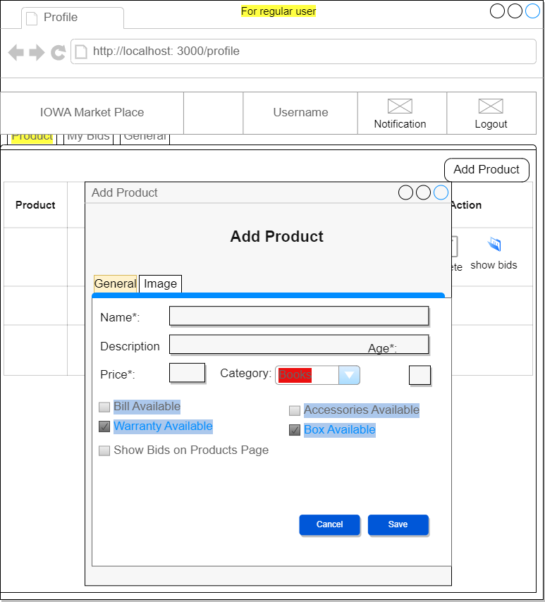

1. **Edit Product Modal**

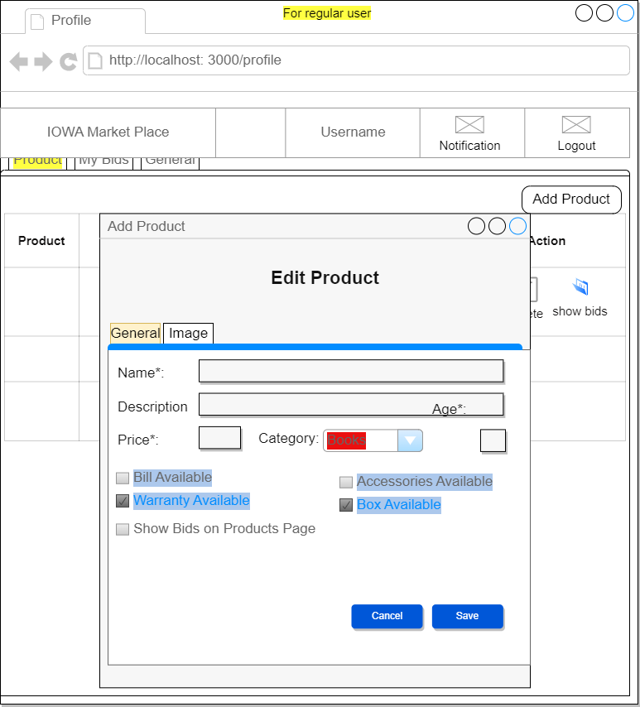

1. **Image Tab Modal**

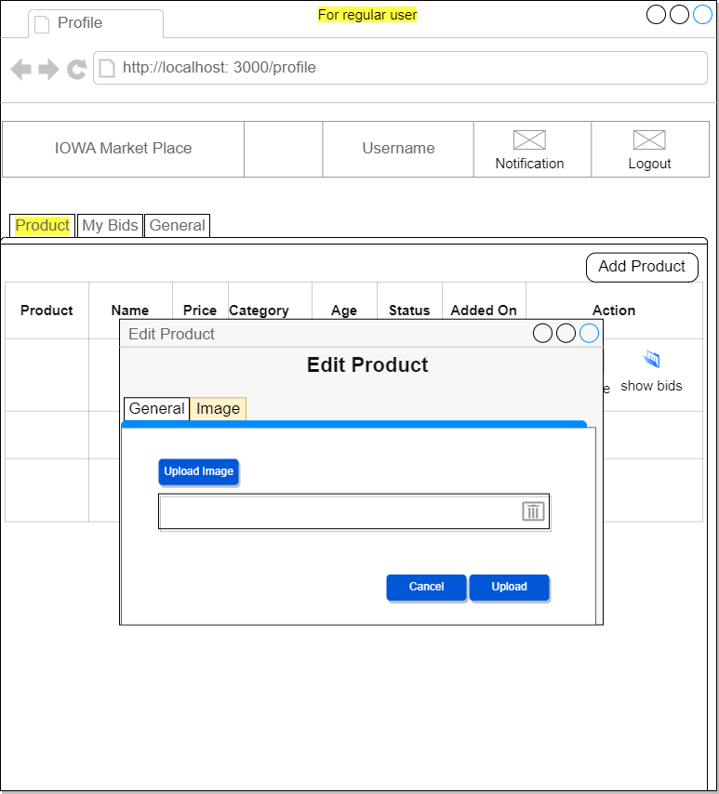

1. **New Bid Modal**

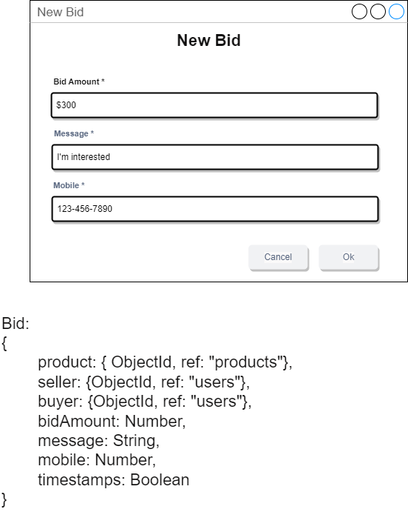

1. **Notification Modal**

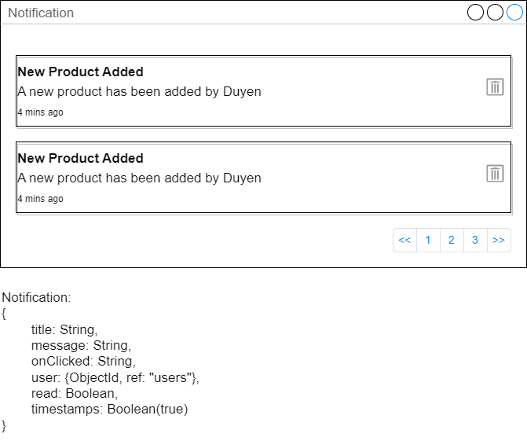

1. **Accepted Bid Notification**

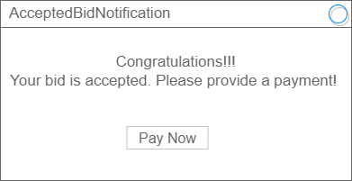

1. **Payment**

